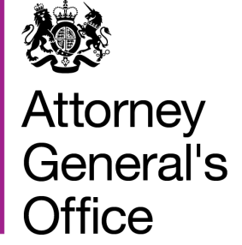 | Rt Hon Geoffrey Cox QC MP  Attorney General
Attorney General’s Office
5-8 The Sanctuary
London
SW1P 3JS
 | Tel: 0207 271 2492
 | www.gov.uk/ago
 | 4 December 2018

Dear colleague,

Yesterday the Government published a detailed legal commentary setting out the legal effect of the Withdrawal Agreement reached in negotiations with the European Union. That legal commentary has been produced with my oversight and approval. I firmly believe it is both an accurate examination of the provisions of the Agreement and a helpful exposition of some of the salient issues that arise from them.

In this letter I will seek to address the issue which has attracted the most controversy – the Protocol on Northern Ireland - in a way that I hope will help with understanding the legal effect of this part of the Withdrawal Agreement. The Protocol would come into force, if needed, on the conclusion of the Implementation Period, which is scheduled to end on 31 December 2020 unless, pursuant to Article 132 of the Agreement, both the UK and the EU agree to a single extension for a fixed time of up to one or two years.

By Article 1.4, the Protocol is expressly agreed not to be intended to establish a permanent relationship but to be temporary. This temporariness should be seen in the context of the obligation of both parties under Article 184 of the Agreement, reinforced by Article 2.1 of the Protocol, to negotiate expeditiously and use their best endeavours in good faith to conclude an agreement in line with the Political Declaration that supersedes the Protocol by the 31 December 2020.

The language used throughout reflects the fact that Article 50 of the Treaty on the European Union does not provide a legal basis in Union law for permanent future arrangements with non-member states. An obligation to use best endeavours in good faith would be arbitrable in the event that clear and compelling evidence showed that it was not being observed.

If either party did not comply with those obligations to bring forward a subsequent agreement, it would be open to them to bring a complaint under the procedures in the Agreement. After the implementation period the complaint would be brought under the Dispute Settlement Provisions set out in Articles 164 to 181 of the Agreement. These include independent arbitration.

If the Protocol were to come into force, it would continue to apply in international law unless and until it was superseded by the intended subsequent agreement, which achieves the stated objectives of maintaining the necessary conditions for continued North-South cooperation, avoiding a hard border and protecting the Belfast Agreement in all its dimensions. There is, therefore, no unilateral right for either party to terminate this arrangement.

It is worth noting that the exact nature of this subsequent agreement could take a number of forms. These are not set out explicitly beyond the objectives which they must meet, however, the Protocol acknowledges that there may be “alternative arrangements” which could take the form of the subsequent agreement to replace the backstop in whole or in part but without necessarily being the full future relationship envisaged under Article 184 of the Agreement.

Under the Protocol, the UK would form a single customs territory for goods with the EU for fiscal or tariff purposes. Accordingly, Northern Ireland would form part of the same customs territory as Great Britain with no tariffs, quotas, or checks on rules of origin either between Great Britain and Northern Ireland or between Great Britain and the EU.

However, Northern Ireland would additionally apply specified parts of the EU’s Single Market rules relating to the regulation and control of the supply of electricity on the island of Ireland, goods, including cross-border VAT rules, and the EU’s Customs Code. This would avoid the need for any hard border and entitle goods originating in Northern Ireland to free circulation throughout the EU single market. In all other aspects of its regulatory regime, Northern Ireland would follow the applicable UK legislation, save where these were devolved. But there can be no doubt that these provisions for Northern Ireland cannot exist without the underpinning UK wide single customs territory.

By Article 7, a Northern Ireland business would also enjoy the same free circulation of its goods throughout the United Kingdom, while its EU competitor, whether situated in the Republic of Ireland or elsewhere, would not.

Article 20 of the Protocol contains a review provision, under which the parties may decide that the Protocol should cease to apply if it is no longer necessary to achieve its objectives as set out in Article 1(3). When making this judgement, both parties must act in good faith. If either side believed the other had not done so, they could refer the decision to an arbitration panel which could decide whether a party had acted lawfully in reaching a view about whether the Protocol was necessary to achieve its objectives. Such a tribunal would only find a breach of the duty of good faith if there was a very clear basis for doing so.

It is important to note that I do not believe that the backstop as constructed would ever be a comfortable resting place for the EU if it were ever to come into force. First, the EU has consistently argued that the Article 50 legal base cannot provide for a lasting relationship, meaning the risk of a legal challenge to the backstop increases the longer it is in place for. Secondly, the enforcement of the single customs territory in respect of Great Britain is left to UK authorities and to the arbitration panel – not the EU institutions. Meaning the integrity of the EU’s customs area is outsourced to a third country outside it's oversight. Thirdly, and finally, it provides for no tariffs, quotas or checks on rules of origin without any harmonisation of rules, minimal level playing field commitments and without any access for EU fishermen to UK waters.

For all these reasons, while the backstop is undoubtedly not a preferred outcome for the UK it is certainly also not a preferred outcome for the EU. There is a suitable balance of risk taken on by both sides with regards to the provisions in the backstop such that I am of the view that neither would want to see it enter into force, or if it were to, for it to endure for very long. This is not something which could be said of earlier drafts of the Protocol.

Fundamentally, the divorce and separation of nations from long unions, just as of human beings, stirs high emotion and calls for wisdom and forbearance. It calls also for calm and measured evaluation by the House of the terms of the separation agreement in the light of the complexity and difficulty of the task it is intended to achieve.

The gradual loosening and removal of the legal ties that have bound us to the European Union for 45 years will take time to work out. This must also be seen in the context where the UK and Ireland have to meet their continued commitments under the Belfast/Good Friday Agreement, further adding to the complexity of such a task.

This Withdrawal Agreement, and the EU Withdrawal Act already passed by the House, allow for the necessary time and legal means for that process to unfold in a peaceful and orderly way. That can only be to the benefit of all of our citizens.

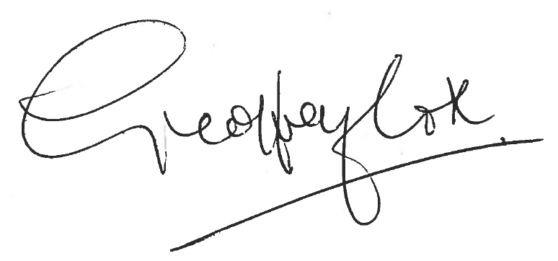

RT HON GEOFFREY COX QC MP
ATTORNEY GENERAL

